Urban Ladder – PL1

Pre-requisite:

As soon as you import the project in Eclipse, update the project using the maven update option as below. This is to resolve the issue if any Maven dependency not downloaded properly:

1. Right-click on the project: Go to “Maven” and select “Update Project”

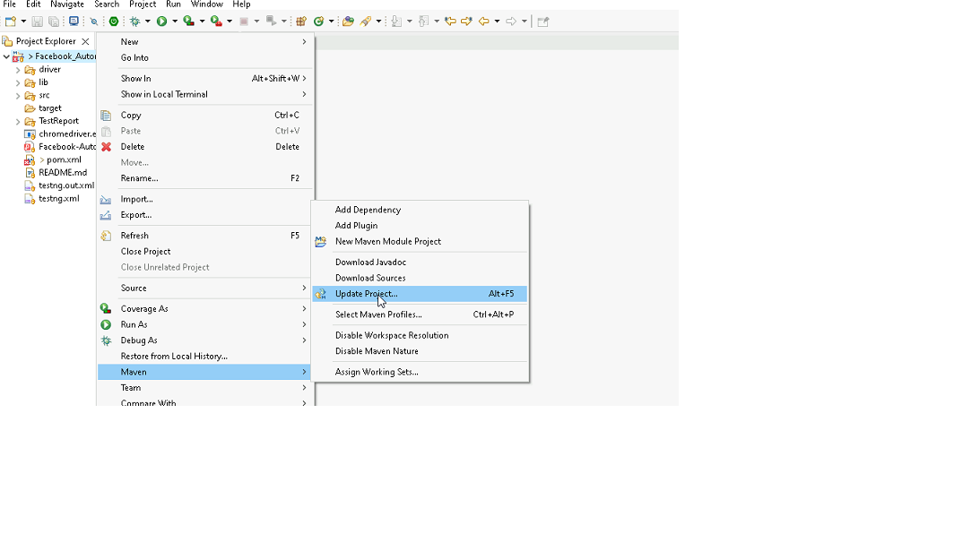

1. In Update Maven Project Box Select “Force Update of Snapshots/Releases” and click OK

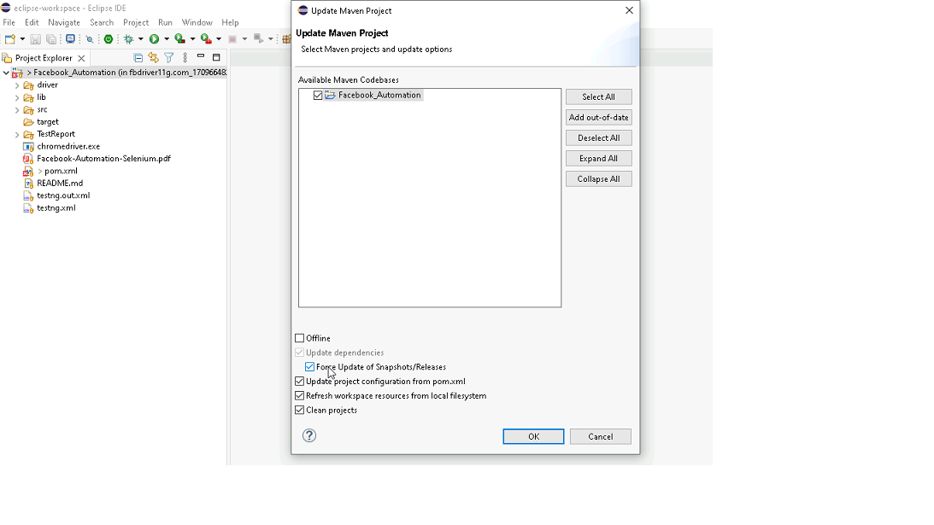

Template Code Structure:

1. Below are the packages and files you will be required to work on.
2. Other Files and packages you can ignore.
3. In other Files and packages do not make any changes. It would affect your evaluation.
4. You are not required to work in the “Test” Folder. The files there are non-editable. Editing those files and trying to save them will throw errors and affect your evaluation.

|  |  |  |
| --- | --- | --- |
| **Package** | **Class/File** | **Description** |
| src/main/java/coreUtilities/utils/ | FileOperations.java | 1. Contains methods to read from excel file. 2. Method is in templated form. 3. **You will be required to implement these methods as very first activity, because even URL to navigate to, is read using these methods.** |
| /src/main/java/pages | FooterPage.java  HomePage.java  SearchPage.java  SignupPage.java | 1. All core activities (mentioned in list above) to be performed here. 2. The comments associated with each templated method here describe the expectation. 3. You can define locators and xpath here. 4. Declare any variable/object you need to share data/status between different methods. 5. Do not modify the signature of methods declared here. 6. You can create additional supportive common methods. |
| /src/main/resources/ | Config.xlsx | URL to navigate to. Already URL is defined here |
|  | expected_data.xlsx | Contains data to fill in form |
|  | testng_1.xml | Execution needs to kick started from testng_1.xml |

PROBLEM STATEMENT:

We need to automate the following activities using Java + Cucumber.

Key Activities to implement:

|  |  |  |  |
| --- | --- | --- | --- |
| **Sl No.** | **Summary** | **Action** | **Expected Result** |
| **1** | Verify that the homepage loads successfully. | * Given I am on the homepage of Urban Ladder. * Then The page title should contain "Urban Ladder". | The homepage of Urban Ladder should load successfully, and the page title contains 'Urban Ladder'. |
| **2** | Verify user can sign up successfully. | * Given I am on the homepage of Urban Ladder. * When Hover on the profile icon * Click on the Sign Up button * Complete the signup process with email and password "Testing1!" * Verify My Account is visible | "My Account" should be visible on the homepage after successfully completing the sign-up process with the specified credentials on Urban Ladder. |
| **3** | Verify user can LOG OUT successfully. | * Given I am on the homepage of Urban Ladder. * When Hover on the profile icon * And Click on the Sign Up button * And Complete the signup process with email and password "Testing1!" * Then Verify My Account is visible * And Click on logout button * Then Verify Login button is visible | User successfully logs out and sees the Login Button on the Urban Ladder homepage. |
| **4** | Scenario: Verify the search functionality with a valid product | * Given I am on the homepage of Urban Ladder. * I search for "Sofa" from search bar * The search results should display items related to "Sofa" | The search results on Urban Ladder's homepage should display a list of products related to "Sofa." |
| **5** | Scenario: Verify that a product can be added to the Wishlist. | * Given I search for "Table" from search bar * Add the first product in the search results to the wishlist. * The product should be added to the wishlist successfully | The first 'Table' product from the search results should be successfully added to the wishlist. |
| **6** | Verify that the product details page opens. | * Given I am on the homepage of Urban Ladder. * When I search for "Chairs" from search bar and Click on view product button from the search results * The product details page should open with the correct product information | The product details page for 'Chairs' opens with accurate and complete product information displayed. |
| **7** | Verify that price filters work correctly. | * Given I am on the homepage of Urban Ladder. * When I search for "Sofa" from search bar and apply a price filter Then All displayed products should fall within the selected price range | All sofas displayed are within the selected price range after applying the price filter on Urban Ladder's homepage. |
| **8** | Verify product details in the wishlist. | * Given I search for "Table" from search bar * When Add the first product in the search results to the wishlist. * Then Verify the product details in wishlist Page | The expected output of the scenario should confirm that the first product listed under "Table" in the search results is successfully added to the wishlist, and its details (such as name, price, and description) on the wishlist page match those from the search results page. |
| **9** | Verify product can be added to compare section. | * Given I search for "Dining" from search bar * When Add the first product to compare section * Verify the product is added to product compare section | The first product from the "Dining" search results appears in the product compare section. |
| **10** | Verify the functionality of footer links. | * Given I am on the homepage of Urban Ladder. * When Click on the Contact Us link in the footer * The Contact Us page should open with relevant information | The Contact Us page opens displaying relevant contact information such as phone number, email address, and physical address. |

NOTE: “Please do not delete any file in the src folder.  But you are free to add any other file".

Expectations:

1. Learners should write automation script using Java and selenium to automate all the steps in the above question. In other words, automation script should perform all mentioned steps.
2. Learners should not use any tools to create the xpath. They should develop the xpath/cssselector on their own.

IMPLEMENTATION/FUNCTIONAL REQUIREMENT

* 1. **CODE QUALITY/OPTIMIZATIONS**
     1. Associates should have written clean code that is readable.
     2. Associates need to follow SOLID programming principles.

# EXECUTION STEPS TO FOLLOW:

# **You are required to run test cases for applications before final submission, without which project evaluation will not happen.**

1. **You can launch test cases any time as follows:** 
   1. **Go to ../testng_1.xml**
   2. **Right-click on testng_1.xml and run TestNGSuite**

|  |
| --- |
|  |

1. **Before final submission, you are also required to push your code to GIT. Following are the steps to follow:**

|  |
| --- |
|  |

In your project folder, you will find a batch file named git_commands

|  |
| --- |
|  |

Double-click the batch file to run it. It will run the commands to push your code to GIT.

|  |
| --- |
|  |

===============================================================================

All the Best